UR PERCENTILE
Visit : http://groups.yahoo.com/group/urpercentile/
Preparing for entrance exam for top Management Institute ?
Join Us.

LESSON P1066 Time Limit : 20 Minutes
http://groups.yahoo.com/group/urpercentile/

Q1 to Q5 are based on the following graph representing the crop production of a certain district.

.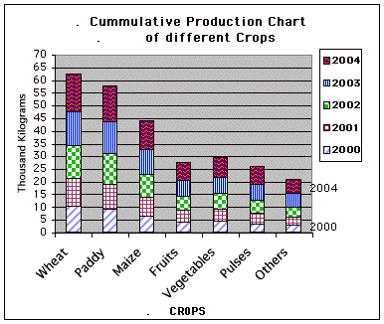

Q1. What was the total production of all the crops in 2001 ?
a) 41400 Kgs b) 45600 Kgs c) 49400 Kgs d) 50800 Kgs

Q2. If year 2000 saw an increase of 10 % in the total production of the crop, what was the production in year 1999 ?
a) 31200 Kgs b ) 30200 Kgs c ) 36180 Kgs d ) 39800 Kgs

Q3. A particular farmer grew 15 % of the maize of the year 2003 and earned Rs 3.00 per Kg of his produce on the maize. Maize income accounted for 40% of his total income for the year 2003. What was his total income for the year 2003.
a)4,500 b)11,250 c ) 10,000 d) 5,500

Q4. In 2004 , what % of the total crop production did wheat account for ?
a) 22 b ) 19 c ) 25 d) 26

Q5. Which year had the minimum total crop production ?
a) 2000 b)2002 c) 2003 d) 2004

http://groups.yahoo.com/group/urpercentile/

Q6 to Q10 are based on the following graph representing the crop production of a certain district.

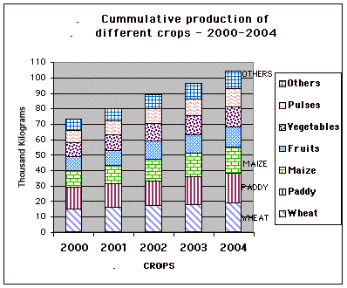

Q6. The total production of paddy for 2000-2004 was 25% more than the production in year 1996-2000 (Both year inclusive). What was the average production in year 1996-200 0?
a) 13120 Kg b) 14850 Kg c) 12120 Kg d) 14580 Kg

Q7. Year 2000 accounted for what % of the total production of the crop for the period 2000-2004 ?
a) 13.5 % b ) 12.5 % c ) 16.5 % d ) 18.5 %

Q8. By how much was the total production of Maize more than the total production of Pulses for the period 2000-2004 ?
a) 19000 b) 21500 c ) 22000 d) 17500

Q9. 10 % of Fruits production and 20 % of paddy production of year 2004 were bought by a particular agent. If the purchasing price of fruits is Rs 15 Per Kg and for Paddy is Rs 10 per Kg, what amount did the agent pay in total.
a) 57500 b ) 52000 c) 62500 d ) 67500

Q10. The forecast for the year 2005 shows that Wheat, Paddy and Maize will show an increase of 10 % while the remaining will show a rise of 20 %. What is the forecast for the total crop production for 2005 ?
a) 119,300 Kg b ) 124,300 Kg c ) 127,300 Kg d ) 126,300 Kg

http://groups.yahoo.com/group/urpercentile/

Q11 to Q15 are based on the following graph representing the crop production of a certain district.

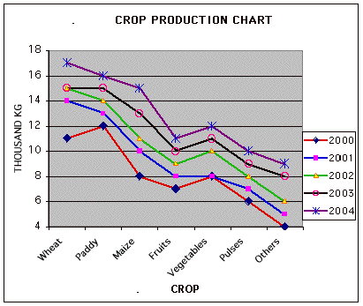

Q11. What is the total production of Vegetables and Pulses in Kgs for the 5 years ?
a) 89,000 b) 86,000 c) 83,000 d) 94,000

Q12. What is the total production of the crop for the year 2000 and 2001 ?
a) 121,000 Kg b ) 116,000 Kg c) 125,000 Kg d)115,000 Kg

Q13. If the year 2000 saw an increase of 20 % in the total production of the crops , what was the total production in year 1999 ?
a) 46,666 Kg b) 48,888 Kg c) 47,777 Kg, d) 45,555 Kg

Q14. Wheat production in 2002 accounted for what % of the total crop production of the year ?
a) 20.5 % b) 18.5 % c) 19.0 % d) 22.0%

Q15. A farmer produced 10 % of the total vegetables in year 2003. If he earned Rs 4 per Kg from his production of vegetables, how much did he earn?
a) 4,100 b) 4,200 c) 4,400 d) 4,600

http://groups.yahoo.com/group/urpercentile/

Q16 to Q20 are based on the following graph representing the crop production of a certain district.

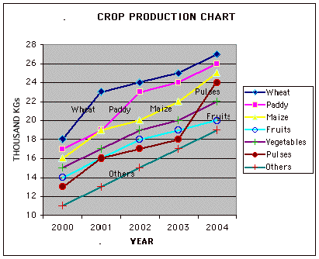

Q16. By how much was Paddy production for the year 2000 to 2004 more compared to Maize production for the same period ?
a) 6,000 Kg b) 7,000 Kg c) 8,000 Kg d) 9,000 Kg

Q17. Pulses accounted for what % of total production for years 2004.
a) 14.7 % b) 13.7 % c) 15.7 % d) 16.7%

Q18. What was the total production of Pulses and Fruits for year 2002 and 2003 ?
a) 72,000 Kg b) 70,000 Kg c) 68,000 Kg d) 69,000Kg

Q19. Year 2005 is forecasted to have a 20 % increase in Fruits and Paddy while the remaining are forecasted to have increase of 10 % except for pulses which is forecasted to remain stable. What is the forecast for the total production for the year 2005 ?
a) 181,500 Kg b) 192,500 Kg c) 175,000 Kg 195,200 Kg

Q20. Year 2000 saw a 10 % increase on each of the crop, what was the total production in year 1999 ?
a) 94,500 b) 95,500 c) 93,500 d) 92,500

http://groups.yahoo.com/group/urpercentile/

MATCH THE WORDS IN SET A WITH THEIR MEANINGS IN SET B

SET A
Q21. vicissitude Q22. Impecunious, Q23. Parsimonious, Q24. Pelf , Q25. Usury 26. Plutocracy , 27. Defalcate 28. Avarice

SET B
A. A person to whom money is to be paid.
B. To estimate the money value of something.
C. Having no money.
D. Unexpected changes in fortune of someone, ups and downs of life.
E. To spend too much of money.
F. Lending of money at a exorbitant rate of interest.
G. A wealthy class controlling the government .
H. Misuse of money held in a trust.
I. Unwilling to spend money, frugal.
J. Collection of money at a religious ceremony.
K. Money, wealth or property obtained dishonestly.
L. A strong desire to get money, be greedy.

http://groups.yahoo.com/group/urpercentile/

ANSWERS :

Ans 1. 11.2+10.1+7.4+4.7+5+4.1+3.1= 45.6*1000= 45,600

Ans 2. 10.2+8.9+6.3+3.9+4.3+3.4+2.8 = 39.8
39.8*100/110 = 36.18.
36.18*1000 = 36,180

Ans 3. (10*15/100)*1000*3 = 4500
Let the income be x. 40X/100 = 4500
so x = 11,250

Ans 4. 15*100/( 15+14.1+11.5+7.1+7.8+7+5.6) = 15*100/68.1= 22 %

Ans 5. Year 2000 had minimum production 39800 Kg.

http://groups.yahoo.com/group/urpercentile/

Ans 6 . Total production of paddy in 2000-2004= 14+15+16+18+19= 82
25X/100 = 82 so x = 65.12
So production in 1996-2000 was 65.12*1000= 65120
Average production in 1996-2000 = 65120/5 = 13120

Ans 7. Production in year 2000 = 73
Production in year 2000-2004, adding up all the figures (73+80+89+96+104) we get 442
% in 2000 = 73*100/442= 16.5 %

Ans 8. Total production of Maize = 11+12+14+15+17= 69
Total production of Pulses = 8+9+10+11+12= 50
Difference = (69-50)*1000 = 19,000

Ans 9. Fruits production in 2004= 13,000
10 % of 13,000 = 1300
Cost for fruits = 1300*15= 19500
Paddy production in 2004= 19*1000= 19000
20 % of 19000= 3800
Cost for 3800 Kg of paddy = 3800 *10 = 38000
Total cost = 19500+38000= 57,500

Ans 10. For year 2004 the production of Wheat, Paddy , Maize, Fruits, vegetables, pulses and others was 19,19,17,,13,13,12 and 11 ( all in '000) Kgs respectively.
Forecast for wheat , paddy and Maize is 20.9,20.9 and 18.7 respectively ( by adding 10 % to each)
Forecast for fruits, vegetable, pulses and others is 15.6,15.6, 14.4 and 13.2 respectively 9 By adding 20 % to each)
Total forecast = 20.9+20.9+18.7 +15.6+15.6+14.4 +13.2 = 119.3
119.3*1000 = 119,300 Kg

Ans 11. Total production of vegetable = 8+8+10+11+12= 49.
Total production of pulses = 6+7+8+9+10 = 40
Total for vegetables and pulse = 49+40 = 89
89*1000= 89,000 Kg

Ans 12. For year 2000 the crop production for wheat , paddy, Maize, Fruits, Vegetables, pulse and Others is 11,12,8,7,8,6 and 4 thousand Kg respectively.
For year 2001 the production for wheat , paddy, Maize, Fruits, Vegetables, pulse and Others is 14,13,10,8,8,7 and 5 thousand Kg respectively.
Adding all these we get 56+65= 121. 121*1000= 121,000 Kg

Ans 13. 20x/100= 56000
so X= 46,666 Kg

Ans 14. Wheat production in 2002 = 15
Total production in 2002= 15+14+11+9+10+8+6= 73
15*100/73 = 20.5 %

Ans 15. Vegetable produced in 2003 = 11,000 Kg
10 % of 11,000 = 1,100.
1,100*4 = 4,400

Ans 16. Paddy production = 17+19+23+24+26= 109
Maize production = 16+19+20+22+25= 102
Difference = 7 . 7*1000 = 7000 Kg

Ans 17. Production of pulses in 2004 = 24
Total production in 2004 = 27+26+25+20+22+24+19 = 163
Pulses % = 24*100/163= 14.7 %

Ans 18. Pulses production in 2002 and 2003 = 17+18= 35
Fruits production in 2002 and 2003 = 18+19 = 37
Total = 35+37 = 72. 72 *1000= 72,000

Ans 19. For year 2004 the crop production for wheat , paddy, Maize, Fruits, Vegetables, pulse and Others is 27,26,25,20,22,24 and 19 thousand Kg respectively.
The forecast for 2005 for wheat , paddy, Maize, Fruits, Vegetables, pulse and Others will be 29.5,31,2,27.5,24,24.2,24,20.9 thousand Kg respectively.
Total forecast for 2005 = 181.5
181.5*1000 = 181,500 Kg

Ans 20. For year 2000 the crop production for wheat , paddy, Maize, Fruits, Vegetables, pulse and Others is 18,17,16,14,15,13 and 11 thousand Kg respectively.
Total production for 2000 = 104*1000 = 104,000
X*110/100 = 104,000
so x = 94,545 approximately equal to 94,500

Ans 21= D, Ans 22= C, Ans 23= I, Ans 24 = K, Ans 25 = F, Ans 26= G, Ans 27= H, Ans 28=L

http://groups.yahoo.com/group/urpercentile/

